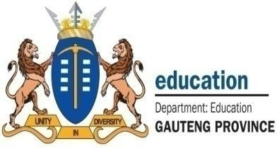


NPO
No: 001041

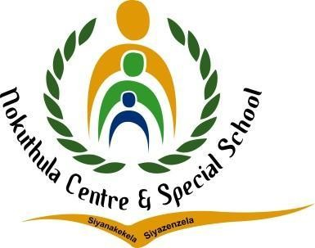
ENGLISH LESSON PLAN

TEL: (011) 444 6443
FAX: (011) 444 6955/2625944
E-MAIL: nokuthulasmh@mweb.co.za

Subject: English |  | Grade: 2 |  | Term: 3 |  |  | Week: 1-3
TOPIC: Transport | Content:  - Listening and Speaking  - Phonological/Phonemic Awareness/Phonics  - Emergent Reading  - Shared Reading  - Handwriting and Writing |  | Time allocation:  2 hours daily |  |  | Date started: |  | Date completed:
Prior content knowledge:  - Learners should have prior knowledge about the different modes of transport.  - Learners use and see different modes of transport every day |  | Lesson objectives: The learners must be able to:  - Understand what transport is.  - Identify animal transport.  - Identify road transport.  - Identify rail transport.  - Identify air transport.  - Identify water transport.  - Compare different types of transport. |  |  | Vocabulary/ important words:  - Transport  - Car  - Bus  - Helicopter  - Train  - Bicycle  - Boat  - Rocket  - Airplane  - On foot |  |  | Teaching strategies:  - Learner centered.  - Question and answer Demonstration


Resources:  - Chalkboard  - Transport chart  - Worksheet  - Big storybook | TEACHER’S ACTIVITIES  Listening and Speaking  - I will introduce the lesson by playing a video about the different modes of transport.  - Ask, how do they travel to school? Write the answers on the board. | LEARNER’S ACTIVITIES  - Learners watch the video about the different modes of transport.  - Learners actively participate in the class discussions and ask clarity seeking questions. | Assessment goal: Assessment strategy: Informal  X  Formal    Assessment tool:  - Rubric
 | Phonemic Awareness
 | - Recognize specific identified sight words from the lesson topic.  - Build and blend words with the taught word families.  - Recognize and name the letters of the alphabet. | - Learners actively listen to the ABC songs and try to identify letters of their own names.  - Learners attempt to answer given activities.
 | Reading  - Read a Big Book about water animals with the learners and ask learners what the story was about. | - Learners read Big Book stories with the teacher. Predict what will happen next in the story using pictorial cues.

 | Handwriting and Writing  - Task learners to trace simple outlines of different modes of transport pictures.  - Give learners patterns (rounded, pointed, vertical lines), letters and words to trace. | - Learners trace simple outlines of different modes of transport and try to draw the different modes of transport.  - learners trace patterns, letter and words.
Differentiation (Enrichment opportunities/ addressing barriers) |  |  | Practical task
- Group 1: Learners will be given an activity to color the pictures of different modes of transport.  - Group 2: learners will be given an activity to match words with pictures of different modes of transport.  - Group 3: Learners will be given an activity to draw and label pictures of each mode of transport. |  |  | Learners will be assigned an activity to paint the pictures of different modes of transport.
Teacher reflection: |  |  | Name of Teacher:
HOD Input: |  |  | Name of HOD:

